**Key People – Ancient Rome**

***Tiberius and Gaius Gracchus***

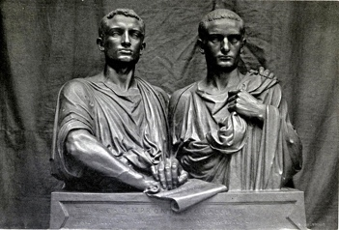

The Gracchi brothers were two brothers at the start of the late Roman Republic: Tiberius Gracchus and Gaius Gracchus. They served in the plebeian tribunates of 133 BC and 122–121 BC, respectively. They have been received as well-born and eloquent advocates for social reform who were both killed by a reactionary political system; their terms in the tribunate precipitated a series of domestic crises which are viewed as unsettling the Roman Republic and contributing to its collapse.

***Gaius Marius***

Gaius Marius (born 157BCE, Cereatae, near Arpinum, Latium – Now Italy- died January 13, 86BCE Rome). He was a Roman general and politician, consul seven times (107, 104 – 100, 86BCE), who was the first Roman to illustrate the political support that a successful general could derive from the votes of his old army veterans. He was acclaimed for saving Rome from collapse, and his military reforms.

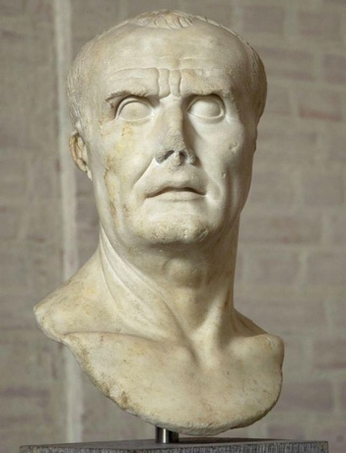

***Sulla***

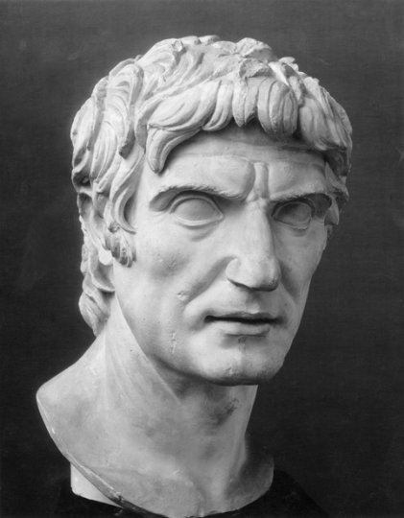

Lucius Cornelius Sulla (born 138BCE and died 79BCE, Puteoli – Puzzuoli, Near Naples Italy). He was a victor in the first full-scale civil war in Roman history (88 – 82BCE) and subsequently dictator (82 – 79BCE) who carried out notable constitutional reforms in an attempt to strengthen the Roman Republic during the last century of its existence. In late 82BE he assumed the name Felix in belief in his own luck. He played an important role in the long political struggle between the optimates and Populares factions in Rome. He was a leader of the optimates, which sought to maintain senatorial supremacy against the populist reforms advocated by the Populares, headed by Marius.

***Pompey the Great***

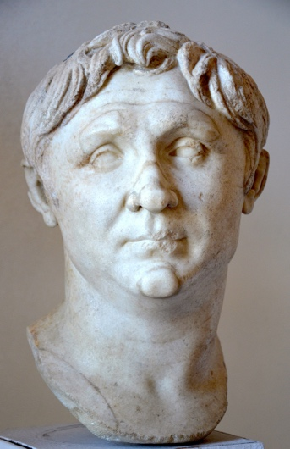

Gnaeus Pompeius Magnus ‘Pompey the Great’ (September 29 106BCE – September 28, 48BCE) was one of the main Roman military leaders and statesmen during the final decades of the Roman Republic. He made a political alliance with Julius Caesar, married his daughter, and then fought against him for control of the empire. He restored Rome’s control over Spain and quelled the Spartacus slave revolt. He eradicated piracy from the Mediterranean, ensuring Rome’s undisputed mastership over the inner sea.